Project Planning Phase

Parameter | Details
Date | 08 March 2026
Team ID
Project Name | VoltEdge: EV Analytics Portal
Maximum Marks | 8 Marks

- Product Backlog, Sprint Schedule, and Estimation (4 Marks)

Sprint | Functional Req (Epic) | USN | User Story / Task | Story Points | Priority | Team Members
Sprint-1 | Data Architecture | USN-01 | As a developer, I can configure the PostgreSQL database to store charging logs and car specs. | 5 | High | Lavani Sardar
Sprint-1 | Data Prep | USN-02 | As a developer, I can perform SQL cleaning to ensure data integrity for the Indian EV market. | 3 | High | Lavani Sardar
Sprint-2 | Analytics Design | USN-03 | As a user (Ravi), I can view a comparative dashboard of EV model efficiency and pricing. | 5 | High | S. Sawant & S. Firake
Sprint-2 | Geo-Mapping | USN-04 | As a user (Aarav), I can see a heatmap of charging station clusters in India. | 5 | High | Lavani Sardar
Sprint-3 | UI/UX Development | USN-05 | As a user, I can navigate the VoltEdge portal using a responsive sticky navbar. | 4 | Medium | Sanskruti Roman
Sprint-3 | Web Integration | USN-06 | As a developer, I can embed Tableau viz objects into the HTML layout using JavaScript. | 8 | High | Lavani Sardar
Sprint-4 | Deployment | USN-07 | As a user, I can submit queries via the Contact Form and receive feedback. | 2 | Low | Sanskruti Roman
Sprint-4 | Performance | USN-08 | As a team, we can test the portal responsiveness across mobile and desktop devices. | 3 | Medium | All Members

2. Project Tracker, Velocity & Burndown Chart (4 Marks)
Sprint | Total Story Points | Duration | Sprint Start Date | Sprint End Date (Planned) | Points Completed | Actual Release Date
Sprint-1 | 8 | 2 Days | 03 March 2026 | 04 March 2026 | 8 | 04 March 2026
Sprint-2 | 10 | 2 Days | 05 March 2026 | 06 March 2026 | 10 | 06 March 2026
Sprint-3 | 12 | 2 Days | 07 March 2026 | 08 March 2026 | 12 | 08 March 2026
Sprint-4 | 5 | 1 Day | 09 March 2026 | 09 March 2026 | 5 (In Progress) | 09 March 2026
Total Points: 35
Average Velocity: 8.75 points per sprint.

3. Velocity Calculation
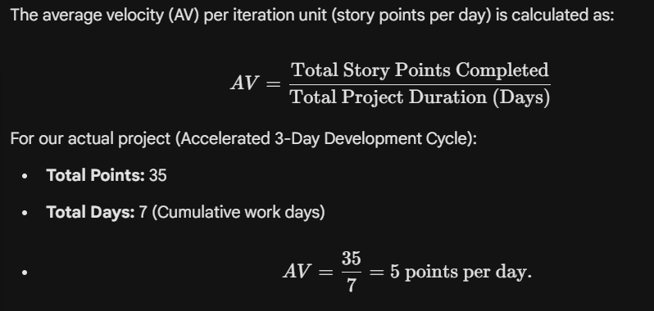

4. Burndown Chart
The Burndown Chart tracks the remaining work (Backlog) against the project timeline.
- Ideal Burn Line: A diagonal line descending from 35 points to 0 points over the project duration.
- Actual Burn Line (VoltEdge Progress):
  - Start: 35 points remaining.
  - End of Sprint-1: 27 points remaining.
  - End of Sprint-2: 17 points remaining.
  - End of Sprint-3: 5 points remaining.
  - End of Sprint-4: 0 points remaining.

